**Exam Automation System**

**By**

**S. Sadrul Hossain**

**ID: 131-15-2402**

**Uzzal Kar**

**ID: 131-15-2302**

**Md. Rasel Ali**

**ID: 131-15-2218**

**Sahanaj Akter**

**ID: 123-15-1994**

This Report Presented in Partial Fulfillment of the Requirements for the Degree of Bachelor of Science in Computer Science and Engineering

Supervised By

**Md. Riazur Rahman**

Lecturer]

Department of CSE

Daffodil International University



**DAFFODIL INTERNATIONAL UNIVERSITY**

**Dhaka, BANGLADESH**

**December, 2016**

# APPROVAL

This Project Titled **“Exam Automation System”** submitted by   
S. Sadrul Hossain, ID: 131-15-2402; Uzzal kar, ID: 131-15-2302; Md. Rasel Ali,   
ID: 131-15-2218 and Sahanaj Akter, ID: 123-15-1994 to the Department of Computer Science and Engineering, Daffodil International University, has been accepted as satisfactory for the partial fulfillment of the requirement for the degree of B.Sc. in Computer Science and Engineering and approved as to its style and contents. The presentation has been held on December, 2016.

**BOARD OF EXAMINERS**

**(Name)** **Chairman**

**Designation**

Department of CSE

Faculty of Science & Information Technology

Daffodil International University

**(Name) Internal Examiner**

**Designation**

Department of CSE

Faculty of Science and Information Technology

Daffodil International University

**(Name) Internal Examiner**

**Designation**

Department of CSE

Faculty of Science and Information Technology

Daffodil International University

**(Name) External Examiner**

**Designation**

Department of …….

University of Dhaka

**DECLARATION**

We hereby declare that, this project has been done by us under the supervision of **Md.** **Riazur Rahman, Lecturer, Department of CSE, Daffodil International University.** We also declare that neither this project nor any part of this project has been submitted elsewhere for award of any degree or diploma.

**Supervised by:**

**C:\Users\Sadrul Hossain\Downloads\supervisersign.jpg**

**(Md. Riazur Rahman)**

Lecturer

Department of CSE

Daffodil International University

# Submitted by:

**Name: S. Sadrul Hossain**

**ID: 131-15-2402**

Department of CSE

Daffodil International University

**Name: Uzzal Kar**

**ID: 131-15-2302**

Department of CSE

Daffodil International University

**Name: Md. Rasel Ali**

**ID: 131-15-2218**

Department of CSE

Daffodil International University

**Name: Sahanaj Akter**

**ID: 123-15-1994**

Department of CSE

Daffodil International University

**ACKNOWLEDGEMENT**

First we express our heartiest thanks and gratefulness to almighty Allah for his divine blessing makes us possible to complete this project successfully.

We feel grateful to and wish our profound indebtedness to **Md. Riazur Rahman, Lecturer**, Department of CSE, Daffodil International University, Dhaka. Deep knowledge and keen interest of our supervisor in the field of Web Development influenced us to carry out this project. His endless patience, scholarly guidance, continual encouragement, constant and energetic supervision, constructive criticism, valuable advice, reading many inferior draft and correcting them at all stage have made it possible to complete this project.

We would like to express our heartiest gratitude to **Prof. Dr. Syed Akhter Hossain**, Head of the Department of CSE, Daffodil International University. For his kind help to finish our project and also to other faculty member and the staffs of CSE department of Daffodil International University.

We would like to thank our all course mate in Daffodil International University, who took part while completing the course work.

Finally, we must acknowledge with due respect the constant support and patience of our parents.

**ABSTRACT**

Examination is one of the most important part of an education system. Examination is vital to evaluate the knowledge of the students and what they have learnt in a course. Examination Control board has to make plans for the examination such as invigilators’ duty plan, students’ seat plan and exam routine. The project “Exam Automation System” deals with the implementation of fully web-based examination automation system for Daffodil International University. The aim of this project is to perform above mentioned examination processes automatically process using a web-based system. This project can help to create invigilators’ duty plan, students’ seat plan that reduce time consumption, labor and make the process faster. This project will be more secure, reliable and fruitful system for the examination control board of Daffodil International University.

**TABLE OF CONTENTS**

|  |  |
| --- | --- |
| **CONTENTS** | **PAGES** |
| Board of Examiners | ii |
| Declaration | iii |
| Acknowledgement | iv |
| Abstract | v |
|  |  |
| **LIST OF FIGURES** | **ix** |
|  |  |
| **CHAPTER** |  |
| **CHAPTER 1: INTRODUCTION** | **1-4** |
| 1.1 Introduction to The New System | 1 |
| 1.2 Objective | 2 |
| 1.3 Scope | 3 |
| 1.4 Methodology | 3 |
| 1.5 Problem Identification of Current Process | 3 |
| 1.6 Organization of the Document | 4 |
|  |  |
| **CHAPTER 2: FEASIBILITY STUDY** | **5-7** |
| 1.1 Feasibility of The New System | 5 |
| 1.2 Technical Feasibility | 5 |
| 1.3 Operational Feasibility | 6 |
| 1.4 Economic Feasibility | 7 |
|  |  |
| **CHAPTER 3: SYSTEM ANALYSIS** | **8-11** |
| 3.1 Analysis of User View of The System | 8 |
| 3.1.1 Super User | 8 |
| 3.1.2 Administrator | 8 |
| 3.1.3 Staff User | 9 |
| 3.2 Requirements for Development and Implementation | 9 |
| 3.2.1 Hardware Requirement | 9 |
| 3.2.2 Software Requirement | 9 |
| 3.2.2.1 Server | 10 |
| 3.2.2.2 Scripting Language | 10 |
| 3.2.2.3 Designing Webpage | 11 |
|  |  |
| **CHAPTER 4: SYSTEM DESIGN** | **12-21** |
| 4.1 Database Design | 12 |
| 4.2 Entity-Relationship Diagram | 17 |
| 4.3 Data Flow Diagram | 20 |
|  |  |
| **CHAPTER 5: SYSTEM IMPLEMENTATION** | **22-34** |
| 5.1 Interface & Analysis | 22 |
| 5.1.1 Home Page | 22 |
| 5.1.2 Login and Registration | 23 |
| 5.1.3 Teacher Page | 24 |
| 5.1.4 Course Page | 25 |
| 5.1.5 Batch Page | 26 |
| 5.1.6 Room Page | 27 |
| 5.1. 7 Column Page | 28 |
| 5.1.8 Create Routine Page | 29 |
| 5.1.9 Duty Plan Page | 30 |
| 5.1.10 Seat Plan Page | 31 |
| 5.1.11 Clear Plan Page | 32 |
| 5.1.12 Generated Report | 32 |
|  |  |
| **CHAPTER 6: TESTING** | **35-36** |
| 6.1 Testing of The System | 35 |
| 6.2 Unit Testing | 35 |
| 6.3 Integration Testing | 36 |
| 6.4 System Testing | 36 |
|  |  |
| **CHAPTER 7: CONCLUSION** | **37** |
| 7.1 Discussion | 37 |
| 7.2 Limitation | 37 |
| 7.3 Future Scope | 37 |
|  |  |
| **REFERENCES** | **38** |

**LIST OF FIGURES**

|  |  |
| --- | --- |
| **FIGURES** | **PAGE NO** |
| Figure 1.1: System Development Lifecycle (SDLC) | 2 |
| Figure 4.1.1: batch Table | 12 |
| Figure 4.1.2: col Table | 13 |
| Figure 4.1.3: course table | 13 |
| Figure 4.1.4: department Table | 13 |
| Figure 4.1.5: registration Table | 14 |
| Figure 4.1.6: room Table | 14 |
| Figure 4.1.7: room_allot Table | 15 |
| Figure 4.1.8: routine Table | 15 |
| Figure 4.1.9: slot Table | 16 |
| Figure 4.1.10: studentseat Table | 16 |
| Figure 4.1.11: teacher Table | 17 |
| Figure 4.1.12: teacheset Table | 17 |
| Figure 4.2.1: Entity-Relationship Diagram | 19 |
| Figure 4.3.1: Context Data Flow Diagram | 20 |
| Figure 4.3.2: Level 1 Data Flow Diagram | 21 |
| Figure 5.1.1: Home Page | 22 |
| Figure 5.1.2.1: Login Form | 23 |
| Figure 5.1.2.2: Registration Form | 23 |
| Figure 5.1.3.1: Add Teacher Page | 24 |
| Figure 5.1.3.2: Teacher List Page | 24 |
| Figure 5.1.4.1: Add Course Page | 25 |
| Figure 5.1.4.2: Course List Page | 25 |
| Figure 5.1.5.1: Add Batch Page | 26 |
| Figure 5.1.5.2: Batch List Page | 26 |
| Figure 5.1.6.1: Add Room Page | 27 |
| Figure 5.1.6.2: Room List Page | 27 |
| Figure 5.1.7.1: Add Column Page | 28 |
| Figure 5.1.7.2: Column List Page | 28 |
| Figure 5.1.8.1: Create Routine | 29 |
| Figure 5.1.8.2: View Routine | 29 |
| Figure 5.1.9.1: Create Duty Plan | 30 |
| Figure 5.1.9.2: View Duty Plan | 30 |
| Figure 5.1.10.1: Create Seat Plan | 31 |
| Figure 5.1.10.2: View Seat Plan | 31 |
| Figure 5.1.11: Clear Plan Page | 32 |
| Figure 5.1.12.1: Report of Duty Plan | 33 |
| Figure 5.1.12.2: Report of Seat Plan | 34 |

**CHAPTER 1**

**INTRODUCTION**

* 1. INTRODUCTION TO THE NEW SYSTEM

Exam Automation System is used to automate the process of creating invigilators’ duty plan and Student seat plan. This system tends to be completely web base i.e. all work of operation are carried out in a web base browser [1]. One teacher from each department of the university works as admin in system for his/ her department who can only create invigilators’ duty plan and Student seat plan for his/ her department. Other teacher can see the prepared plan.

System Development Life Cycle (SDLC) is the overall process of developing information systems through multi-user process from feasibility study, investigation of requirements through analysis, design, implementation, testing and maintenance. In this system development life cycle system analysis and design of the proposed system are the key concern. Software is a group of program that can automate a system. Software may automate a system fully or it may automate a part of a system. Therefore software and system development are very much related to each other [2].

Software development is a complicated process. It requires careful planning and execution to meet the goals. Sometimes a development must react quickly and aggressively to meet ever changing market demands. Maintaining Software quality hinders fats paced software development, as many testing cycle are necessary to ensure quality products. There are many stage of software development. A commercial software product is usually provide for marketing demands. Sales and marketing people have firsthand knowledge of their customer`s requirement. Based upon these market requirements, scenario software creates architecture for the products along with the function and design specifications. Then the development process starts. After the initial development phase, software testing begins and many times it done in parallel with the development process. Documentation is also part of the software development a product cannot be brought to market without manuals. Once the development and testing are done, the software is release and the supports cycle begins. This phase may including bug fixed and new releases [3].

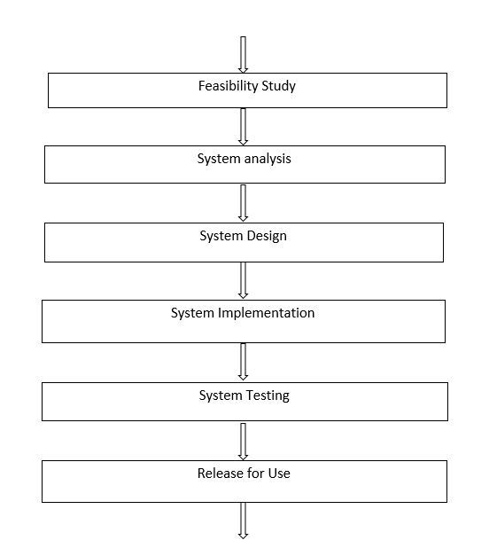

**Figure 1.1: System Development Lifecycle (SDLC)**

* 1. OBJECTIVE

The main objective of our project is to develop a web-based exam automation system for our university. Also we want to apply our programming skill, knowledge and creative idea into some area.

Day by day all the systems are going to be automated. Internet has become an integral part of our life. So by doing this project we can learn how to develop a web-based application of the system.

* 1. SCOPE

This software is comprised of a relational database, software to act on that database, and one graphical interfaces. It uses separate software function discrete Programs called modules, which are then integrated into a unified interface. Examples of modules include: acquisitions (addition, deletion, edition of teacher information; addition, deletion, edition of room; addition, deletion, edition of course; edition of slot). Each teacher and patron has a unique ID in the database that allows the administrator to track its activity [3].

* 1. METHODOLY
* This project is for university examination control board
* We learnt the methods in which the processes are performed manually
* We collected all requirements needed.
* We tried to develop algorithms according to these methods
* We applied those algorithms in PHP.
* Our aim was to turn the manual process in automatic
  1. PROBLEM IDENTIFICATION OF CURRENT PROCESS

There are a lot of problems in present process of creating invigilators’ duty plan and Student seat plan.

* The first problem is it is paper based as a result it is time consuming and problematic.
* It is a manual system.
* All reports publish manually.
* It needs a lot of man power.
* It is very slow and lengthy process.
* It has no security.
  1. ORGANIZATION OF THE DOCUMENT
* Chapter 2 deals with the feasibility study of the system.
* All types of users are determined in chapter 3 and also, the requirements of the system are analyzed in this chapter.
* Chapter 4 is covered with the design of the system which includes the database design, entity relationship and data flow in the system.
* In chapter 5, implementation of the system is shown with several parts of code.
* In chapter 6, it is covered with the analysis of quality of the system through testing.
* In chapter 7, the document is concluded.

**CHAPTER 2**

**FEASIBILITY STUDY**

2.1 FEASIBILITY OF THE NEW SYSTEM

A systems request must pass several tests, called a feasibility study, to see whether it is worthwhile to proceed further. Sometimes a feasibility study is quite simple and can be done in a few hours. If the request involves a new system or a major change, however, extensive fact-finding and investigation is required [4]. A well-designed feasibility study should provide a historical background of the business or project, a description of the product or service, accounting statements, details of the operations and management, marketing research and policies, financial data, legal requirements and tax obligations [5].

2.2 TECHNICAL FEASIBILITY

This assessment is based on an outline design of system requirements, to determine whether the company has the technical expertise to handle completion of the project. When writing a feasibility report, the following should be taken to consideration:

* A brief description of the business to assess more possible factors which could affect the study
* The part of the business being examined
* The human and economic factor
* The possible solutions to the problem
* At this level, the concern is whether the proposal is both technically and legally feasible (assuming moderate cost).

The technical feasibility assessment is focused on gaining an understanding of the present technical resources of the organization and their applicability to the expected needs of the proposed system. It is an evaluation of the hardware and software and how it meets the need of the proposed system [6].

To fulfill the requirements of this project, we need to have knowledge in web related areas. As we have knowledge in PHP, HTML, CSS, JavaScript and JQuery, we were quite hopeful to fulfill all the requirements of the system.

2.3 OPERATIONAL FEASIBILITY

Operational feasibility is a measure of how well a proposed system solves the problems, and takes advantage of the opportunities identified during scope definition and how it satisfies the requirements identified in the requirements analysis phase of system development [4].

The operational feasibility assessment focuses on the degree to which the proposed development projects fits in with the existing business environment and objectives with regard to development schedule, delivery date, corporate culture and existing business processes.

To ensure success, desired operational outcomes must be imparted during design and development. These include such design-dependent parameters such as reliability, maintainability, supportability, usability, producibility, disposability, sustainability, affordability and others. These parameters are required to be considered at the early stages of design if desired operational behaviors are to be realized. A system design and development requires appropriate and timely application of engineering and management efforts to meet the previously mentioned parameters. A system may serve its intended purpose most effectively when its technical and operating characteristics are engineered into the design. Therefore, operational feasibility is a critical aspect of systems engineering that needs to be an integral part of the early design phases [7].

As we know how the processes are performed manually, we designed the system to perform the processes in the same manner automatically.

* 1. ECONOMIC FEASIBILITY

Economic feasibility means that the projected benefits of the proposed system outweigh the estimated costs usually considered the total cost of ownership (TCO), which includes ongoing support and maintenance costs, as well as acquisition costs. To determine TCO, the analyst must estimate costs in each of the following areas:

* + - People, including IT staff and users
    - Hardware and equipment
    - Software, including in-house development as well as purchases from vendors
    - Formal and informal training
    - Licenses and fees
    - Consulting expenses
    - Facility costs
    - The estimated cost of not developing the system or postponing the project.

In addition to costs, we need to assess tangible and intangible benefits to the company. The systems review committee will use those figures, along with our cost estimates, to decide whether to pursue the project beyond the preliminary investigation phase [4].

**CHAPTER: 3**

**SYSTEM ANALYSIS**

3.1 ANALYSIS OF USER VIEW OF THE SYSTEM

System analysis is a detailed study of the various operation performed by the system and their relationship within the system and its outside environment. A key question may come that what must be done to solve the problem? Defining boundaries of the system and determining whether or not a candidate system should consider other related system. During analysis, data are collected on the available files, decision points and transaction handled by the present system.

This Chapter also provide a brief discussion of scope and objective of the proposed system and requirement analysis. A brief overview of technology those have been used for the implementation of the system also include in this chapter

There are three types of users of the “**Exam Automation System**” and there views to the system will be different from their one context.

3.1.1 SUPER USER

The Knowledge worker, namely analysts and programmers, who will meet the management level user needs by designing the database and writing program to extract reports out of the system.

3.1.2 ADMINISTRATOR

The Administrator is the ultimate user of the system. Admin should login to the system to operate. None other than the admin can access to the system who has no login access. A teacher from each department is selected as admin in the system.

3.1.3 STAFF USER

This level of user can only access where authorization is not necessary. This user can only see the report generated by the system.

3.2 REQUIREMENT FOR DEVELOPMENT AND IMPLEMENTATION

To run this software smoothly in practical life we must fulfill some requirements. The requirements are:

1. Hardware requirement
2. Software requirement

3.2.1 HARDWARE REQUIREMENT

One database server must be available to implement the system with following configuration.

Number of PC 1 server class brand PC hosting MySQL

Database Server

Processor Specification Pentium IV Speed 1.2 GHz or above

Memory Specification 1 GB

Hard Disk Specification 100GB

Operating System Windows 7 or above

3.2.2 SOFTWARE REQUIREMENT

1. Windows 7 or above
2. Wamp server or xampp server[PHP, APACHE, MySQL]
3. Notepad ++ , Netbeans etc

3.2.2.1 SERVER

Almost all of the work web application takes place on the server. A specific application, called a web server, will be responsible for communicating with the browser. A relational database server stores whatever information the application requires. Finally, we need a language to broker requests between the web server and database server, it will also be used to perform programmatic tasks on the information that comes to and from the web server. But of course none of this is possible without an operating system. The web server, programming language, and database server we use must work well with the operating system.

There are many web servers out there in the market. To implement exam automation system, APACHE is used, because the apache web server is the most popular web server. PHP will most often run as an apache extension, known as apache module. It is a great web server, and it is extremely fast and amazingly stable.

MYSQL has been used as database in the proposed system. It is cost-effective. It is quick and powerful. It may not have every bell and whistle available for a relational database, but for most users there is plenty.

WAMP or XAMPP server is combination of PHP, APACHE, and MYSQL server.

3.2.2.2 SCRIPTING LANGUAGES

PHP has been used as scripting language as it is easy and fast. PHP has managed the perfect mix power, structure and easy to use. In the end, PHP offers the best opportunity to develop powerful web application quickly. The generalization made, there are other excellent reasons for choosing PHP.

* **Cross-platform:** Most PHP code can be processed without alteration on computers running many different operating systems. For example, a PHP script that runs on windows generally also runs well on Linux.
* **HTML-embedded:** PHP code can be written in files containing a mixture of PHP instructions and HTML code.
* **Server-side:** The PHP programs are run on a server, specifically a web server.
* **Web-scripting language:** PHP programs run via a web browser.

This means, programs that mix PHP code and HTML, run them on a web server, and access them from a web browser that displays the result of PHP processing by showing the HTML returned by run by the web server [8].

3.2.2.2 DESIGNING WEBPAGE

Notepad++, Netbean 8.1 has been used to implement the web page of the proposed system. HTML, JavaScript, JQuery also have been used to build the web page.

**CHAPTER 4**

**SYSTEM DESIGN**

* 1. DATABASE DESIGN

Database of this project has 12 tables. All tables are shown below:

DB_Name: finalproject

1. Figure 4.1.1 shows the following table

Table_name: batch

No_of_attributes: 5

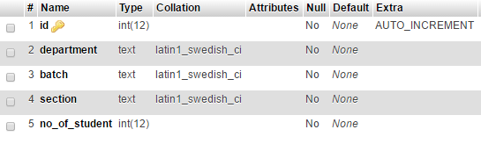

Figure 4.1.1: batch Table

1. Figure 4.1.2 shows the following table

Table_name: col

No_of_attributes: 4

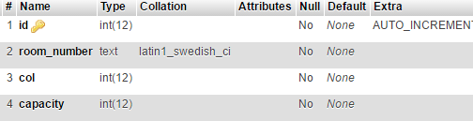

Figure 4.1.2: col Table

1. Figure 4.1.3 shows the following table

Table_name: course

No_of_attributes: 6

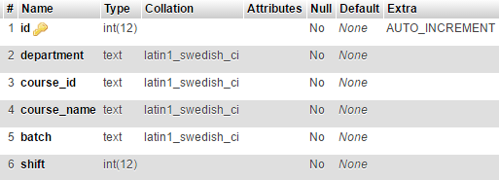

Figure 4.1.3: course Table

1. Figure 4.1.4 shows the following table

Table_name: department

No_of_attributes: 2

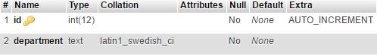

Figure 4.1.4: department Table

1. Figure 4.1.5 shows the following table

Table_name: registation

No_of_attributes: 3

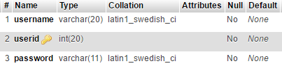

Figure 4.1.5: registation Table

1. Figure 4.1.6 shows the following table

Table_name: room

No_of_attributes: 5

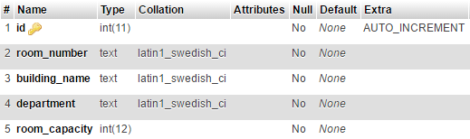

Figure 4.1.6: room Table

1. Figure 4.1.7 shows the following table

Table_name: room_allot

No_of_attributes: 7

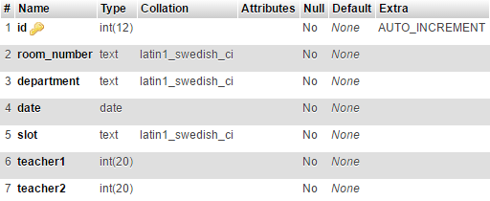

Figure 4.1.7: room_allot Table

1. Figure 4.1.8 shows the following table

Table_name: routine

No_of_attributes: 6

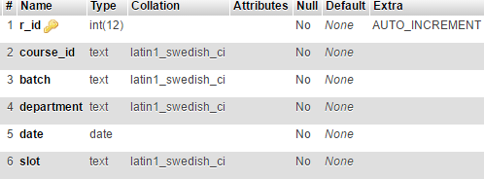

Figure 4.1.8: routine Table

1. Figure 4.1.9 shows the following table

Table_name: slot

No_of_attributes: 4

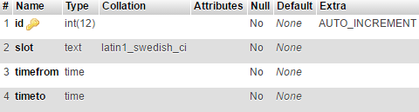

Figure 4.1.9: slot Table

1. Figure 4.1.10 shows the following table

Table_name: studentseat

No_of_attributes: 10

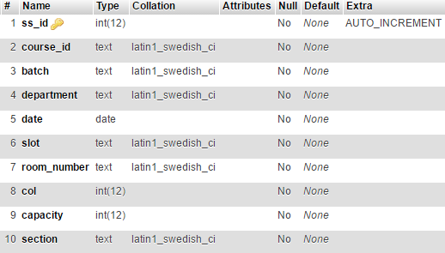

Figure 4.1.10: studentseat Table

1. Figure 4.1.11 shows the following table

Table_name: teacher

No_of_attributes: 7

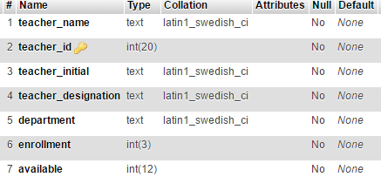

Figure 4.1.11: teacher Table

1. Figure 4.1.12 shows the following table

Table_name: teacherset

No_of_attributes: 3

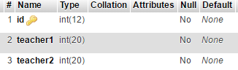

Figure 4.1.12: teacherset Table

* 1. ENTITY-RELETIONSHIP DIAGRAM

An entity-relationship diagram (ERD) is a model that shows the logical relationships and interaction among system entities. An ERD provides an overall view of the system and a blueprint for creating the physical data structures.

Three types of relationships can exist between entities: one-to-one, one-to-many, and many-to-many [9].

Components of ER diagram are:

* Rectangles: which represent entity sets
* Ellipses: which represent attributes
* Diamonds: which represent relationship sets
* Lines: which represent link from attributes to entity sets and entity sets to relationship sets.
* Double Ellipses: which represent multi-valued attributes.
* Dashed Ellipses: which represent derived attributes
* Double Rectangles: which represent weak entity sets [10].

Entity Relationship Diagram of the proposed system is shown in figure 4.2.1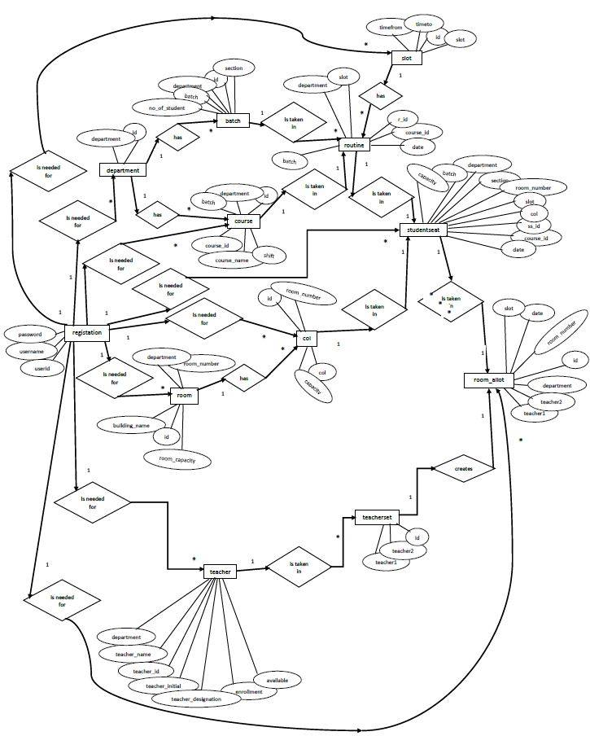

Figure 4.2.1: Entity Relationship Diagram

* 1. DATA FLOW DIAGRAM

A data flow diagram (DFD) uses various symbols to show how the system transforms input data into useful information. A data flow diagram (DFD) shows how data moves through an information system but does not show program logic or processing steps. A set of DFDs provides a logical model that shows what the system does, not how it does it. That distinction is important because focusing on implementation issues at this point would restrict your search for the most effective system design [11].

Components of data flow diagram are:

* Process
* Entity
* Data flow
* Data store

Data Flow Diagram for the proposed system is given below:

Figure 4.3.1 depicts the Context Diagram

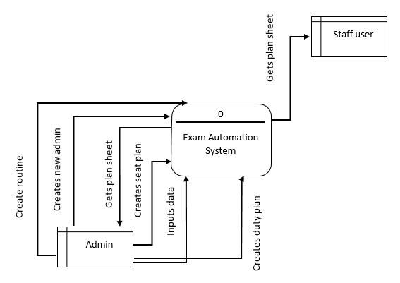

Figure 4.3.1: Context Data Flow Diagram

Figure 4.3.2 depicts Level 1 Diagram

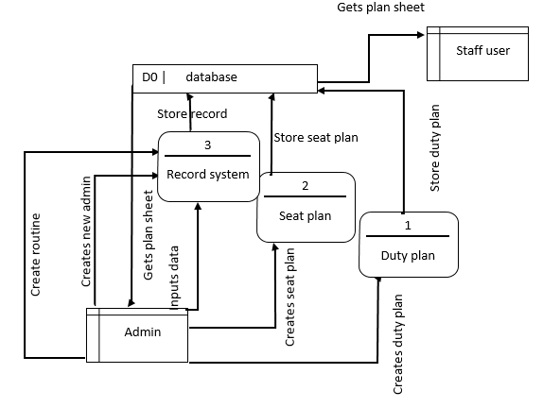

Figure 4.3.2: Level 1 Data Flow Diagram

**CHAPTER 5**

**SYSTEM IMPLEMENTATION**

* 1. INTERFACE AND ANALYSIS

Discussion about the interface of the proposed system is the main purpose of this chapter.

* + 1. HOME PAGE

This page, shown in figure 5.1.1, contains all the links to visit in the system and to perform tasks. Admin page, duty plan page, seat plan page, view plan pages all such pages are connected to this page.

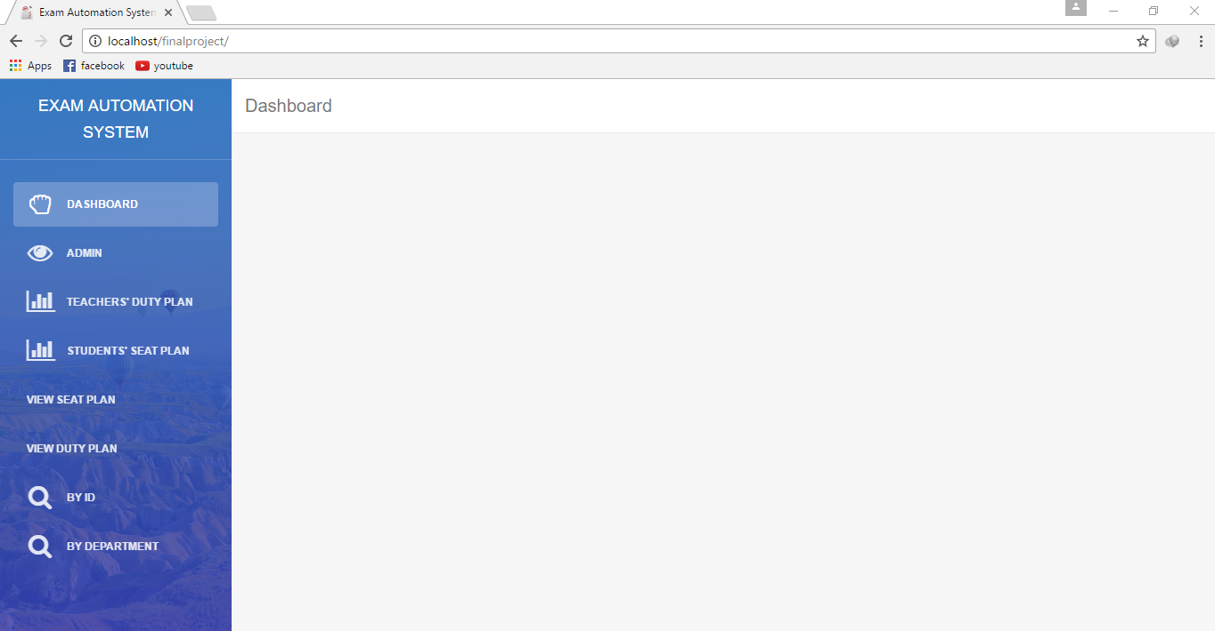

Figure 5.1.1: Home Page

* + 1. LOGIN AND REGISTRATION

Login is needed to access the main system. An admin has the access to enter the main system. No one can access main system without login. An admin can add new admin by registering the new admin in registration page, shown in figure 5.1.2.1 and figure 5.1.2.2.

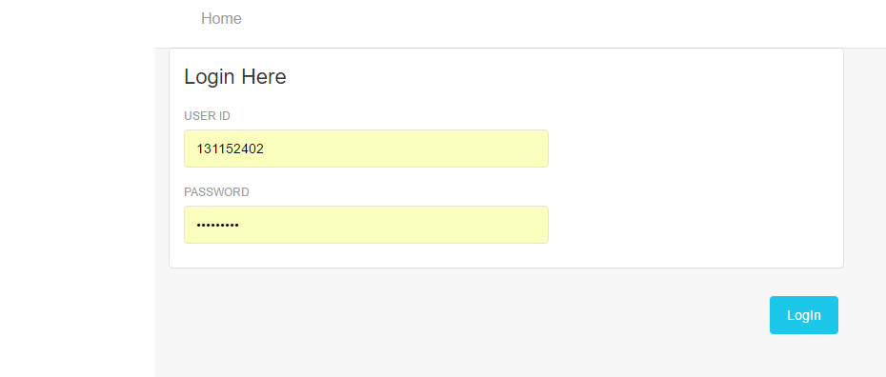

Figure 5.1.2.1: Login Form

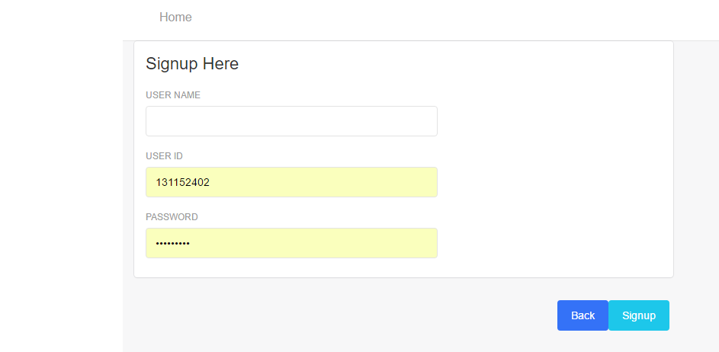

Figure 5.1.2.2: Registration Form

* + 1. TEACHER PAGE

In this page, shown in figure 5.1.3.1 and figure 5.1.3.2, there are options to addition, deletion and edition of teacher information, and to list the teacher information.

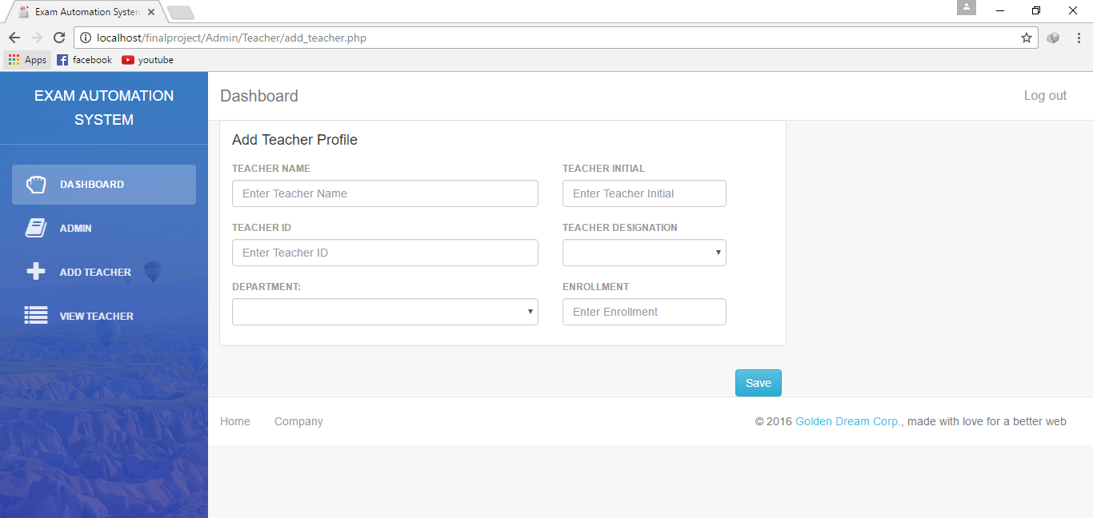

Figure 5.1.3.1: Add Teacher Page

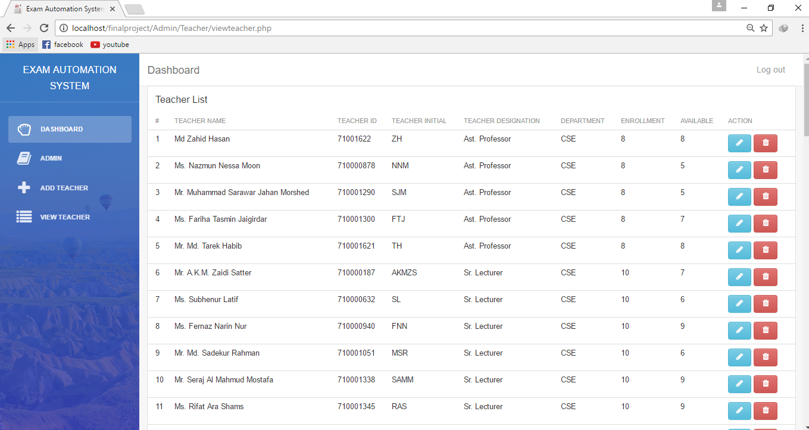

Figure 5.1.3.2: Teacher List Page

* + 1. COURSE PAGE

In this page, shown in figure 5.1.4.1 and figure 5.1.4.2, there are options to addition, deletion and edition of Course information, and to list the Course information.

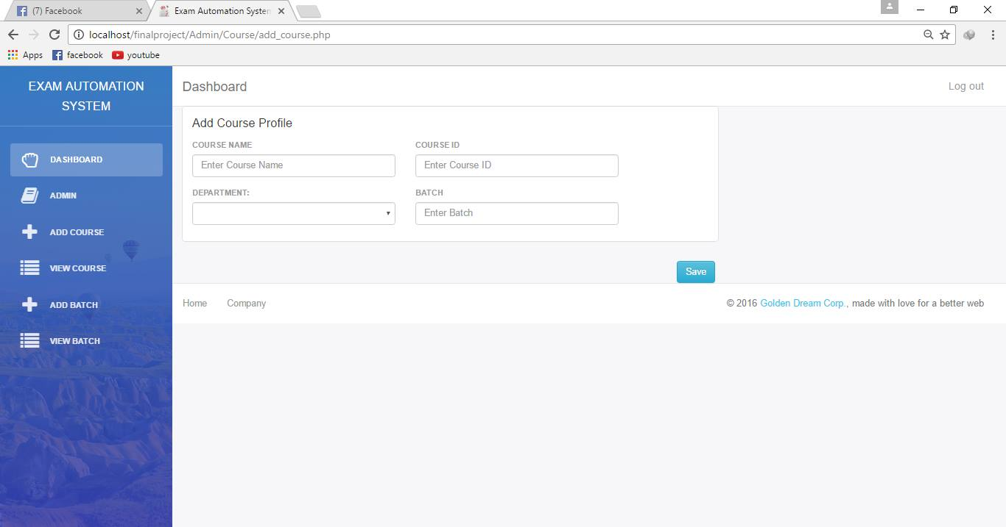

Figure 5.1.4.1: Add Course Page

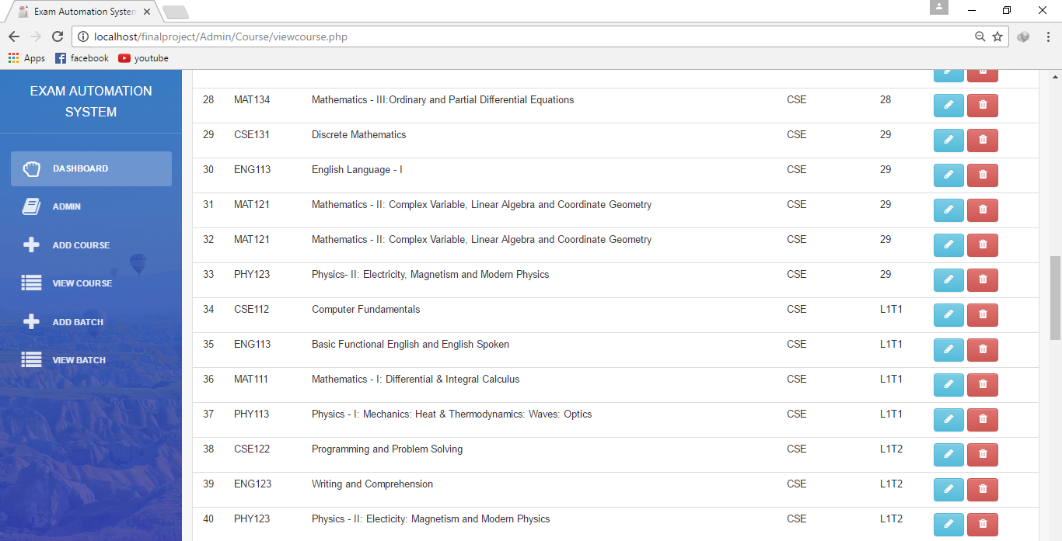

Figure 5.1.4.2: Course List Page

5.1.5 BATCH PAGE

In this page, shown in figure 5.1.5.1 and figure 5.1.5.2, there are options to addition, deletion and edition of Batch information, and to list the Batch information

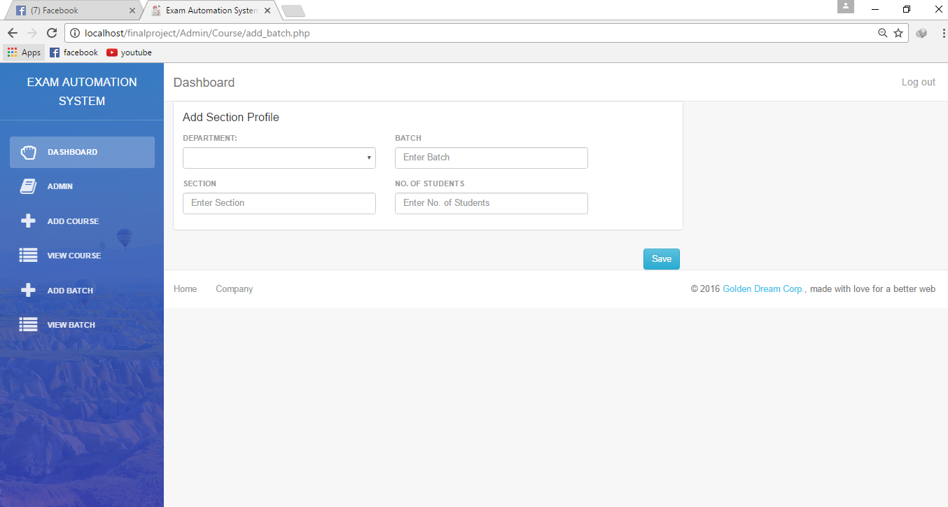

Figure 5.1.5.1: Add Batch Page

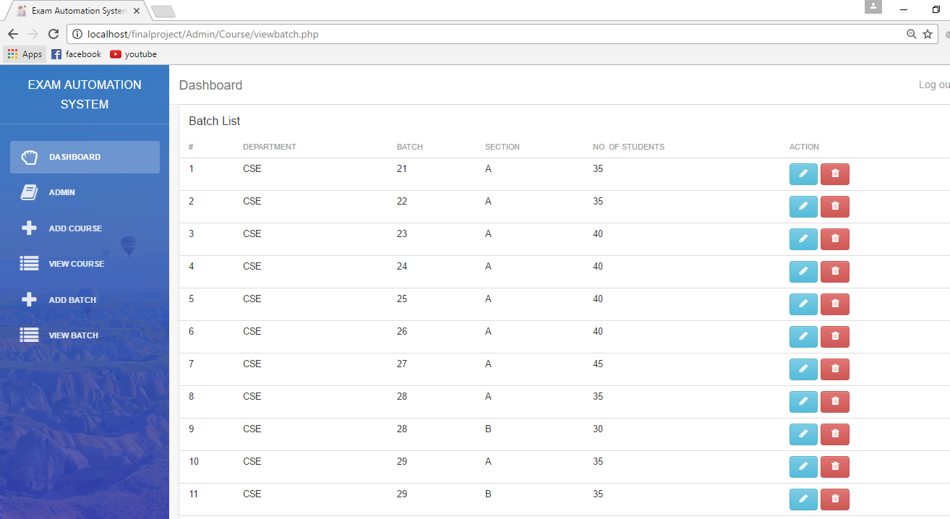

Figure 5.1.5.2: Batch List Page

* + 1. ROOM PAGE

In this page, shown in figure 5.1.6.1 and figure 5.1.6.2, there are options to addition, deletion and edition of Room information, and to list the Room information.

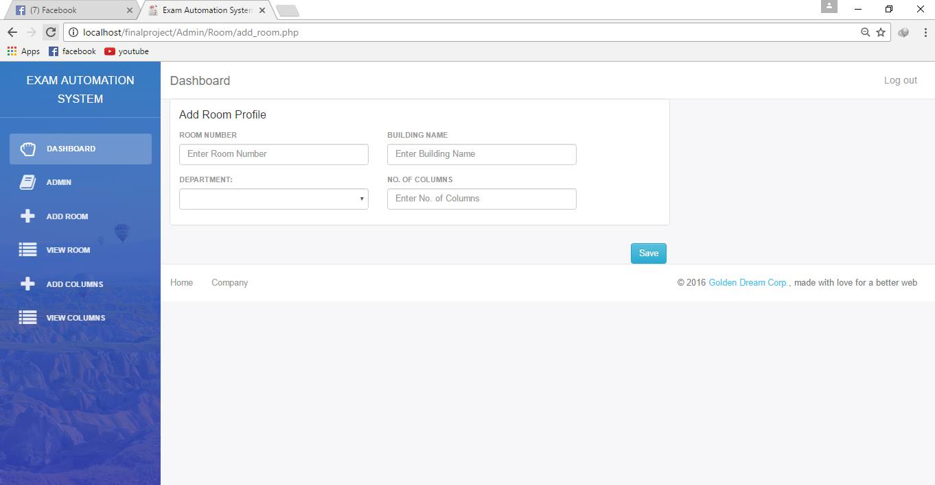

Figure 5.1.6.1: Add Room Page

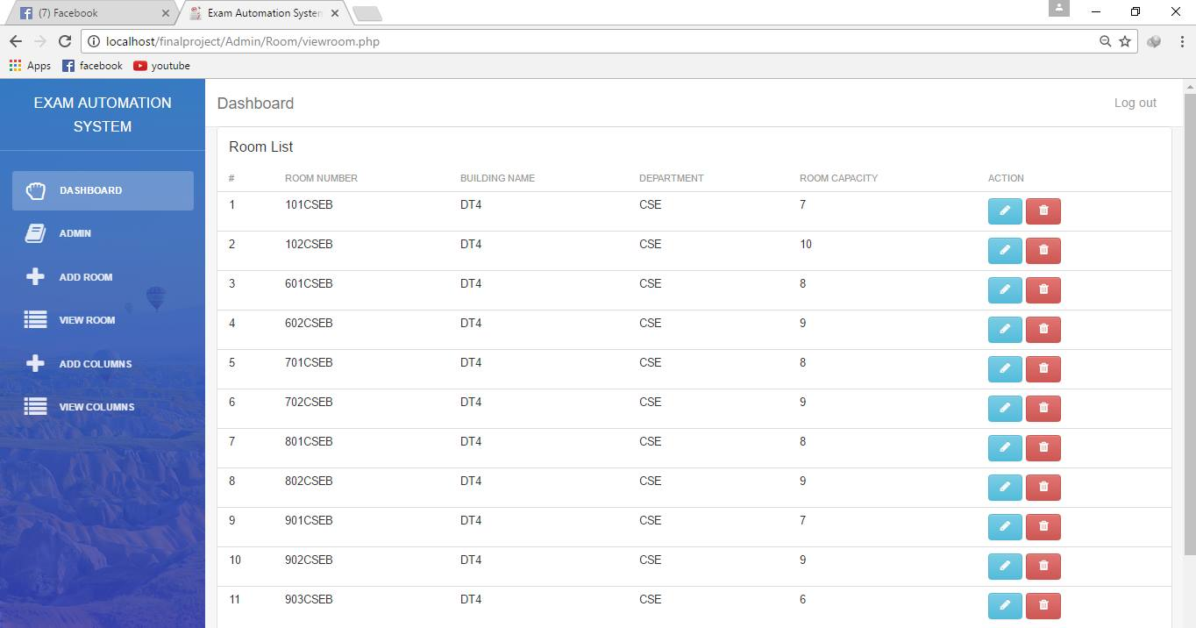

Figure 5.1.6.2: Room List Page

5.1.7 COLUMN PAGE

In this page, shown in figure 5.1.7.1 and figure 5.1.7.2, there are options to addition, deletion and edition of Column information, and to list the Column information.

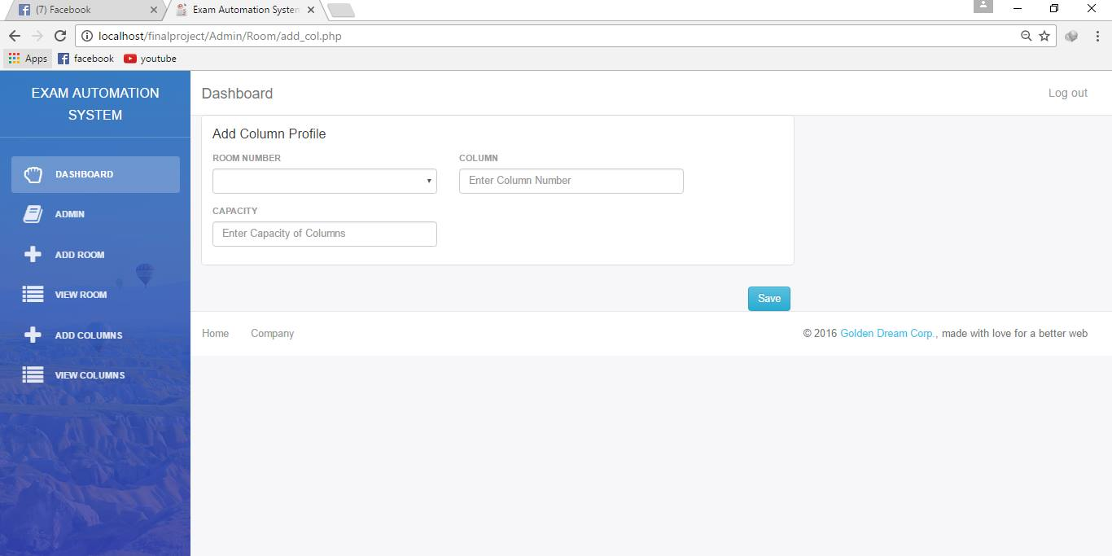

Figure 5.1.7.1: Add Column Page

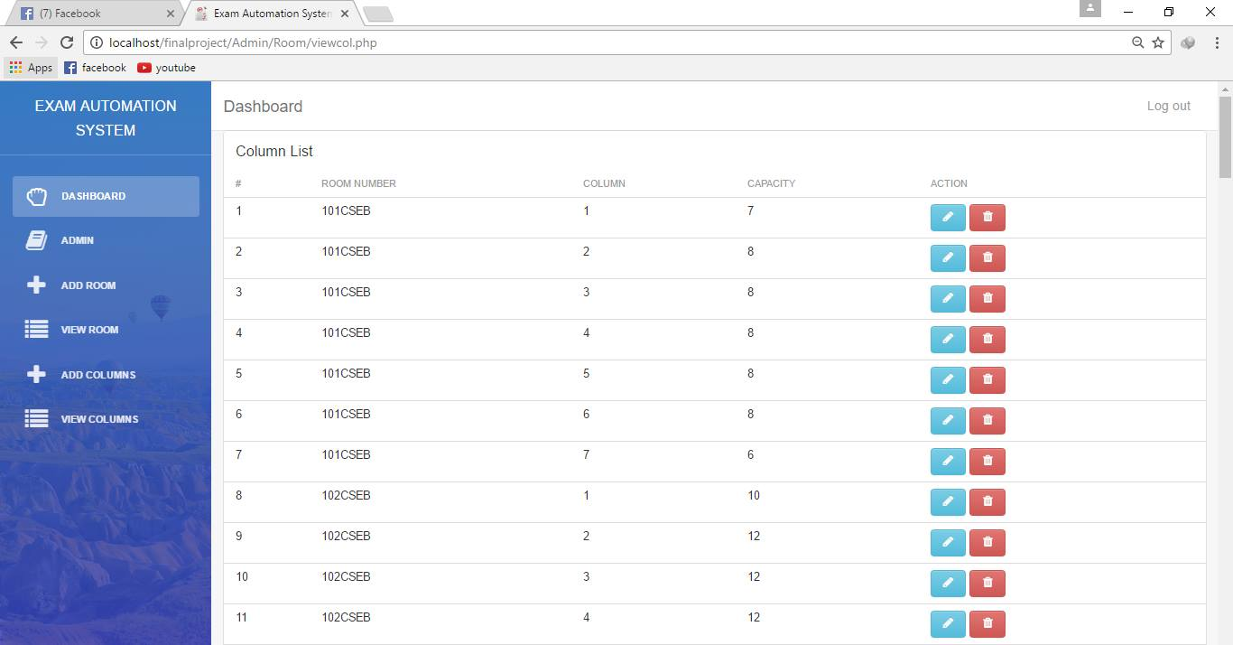

Figure 5.1.7.2: Column List Page

* + 1. CREATE ROUTINE PAGE

In this page, shown in figure 5.1.8.1 and figure 5.1.8.2, we create exam routine and this routine is used for further processes.

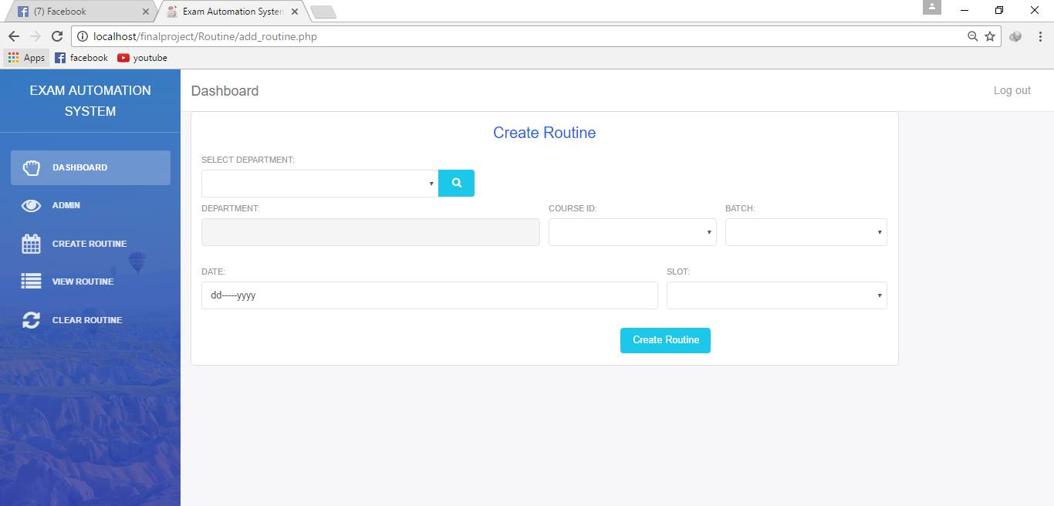

Figure 5.1.8.1: Create Routine

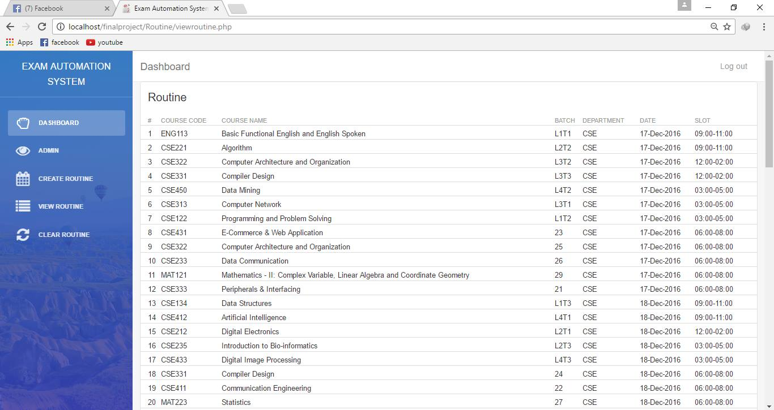

Figure 5.1.8.2: View Routine

* + 1. DUTY PLAN PAGE

Duty Plan page, shown in figure 5.1.9.1, is used to create invigilators’ duty plan of a slot of a date. This plan can be listed in the page, shown in figure 5.1.9.2.

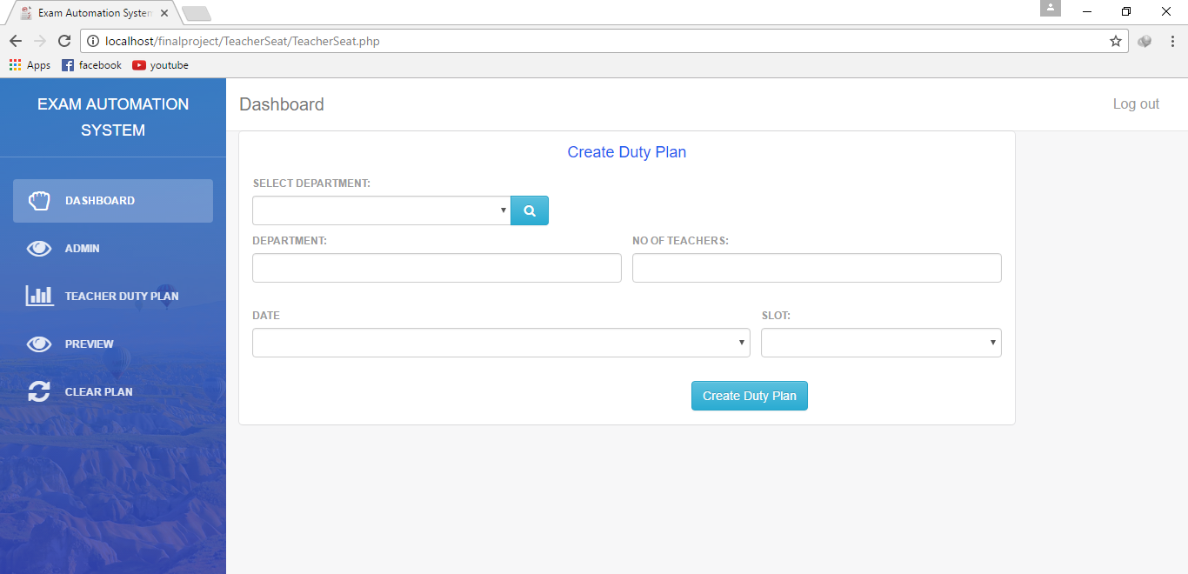

Figure 5.1.9.1: Create Duty Plan

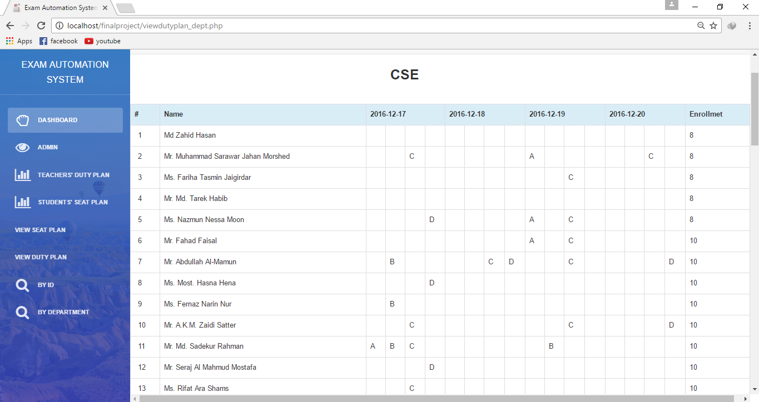

Figure 5.1.9.2: View Duty Plan

* + 1. SEAT PLAN PAGE

Duty Plan page, shown in figure 5.1.10.1, is used to create invigilators’ duty plan of a slot of a date. This plan can be listed in the page, shown in figure 5.1.10.2.

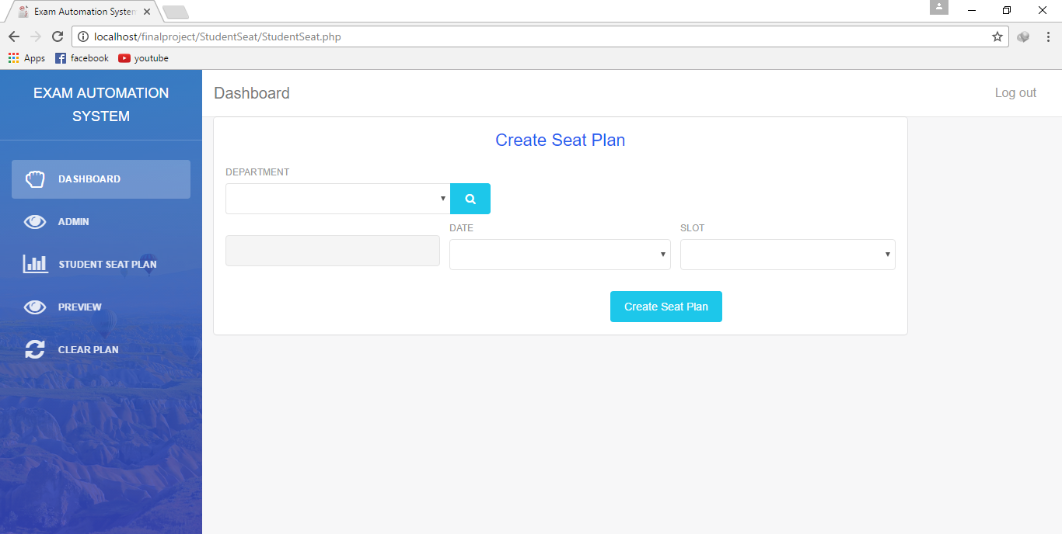

Figure 5.1.10.1: Create Seat Plan

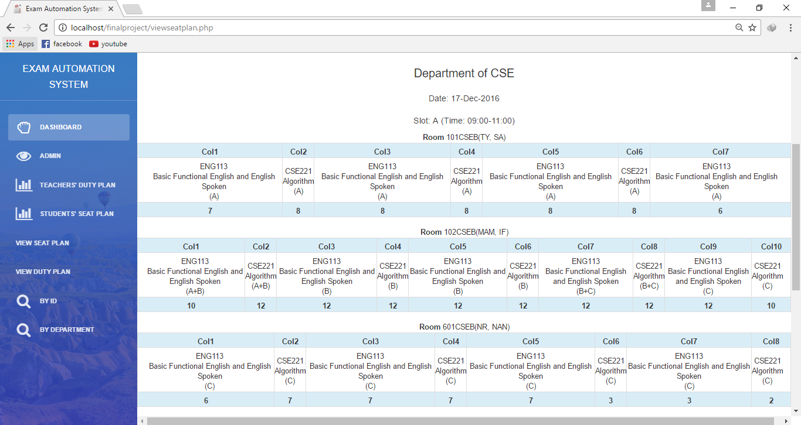

Figure 5.1.10.2: View Seat Plan

5.1.11 CLEAR PLAN PAGE

This page, shown in figure 5.1.11, is attached in all the processes to refresh the process with respect to department.

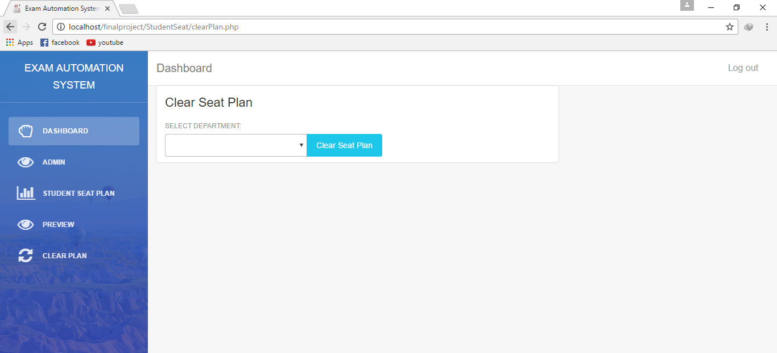

Figure 5.1.11: Clear Plan Page

5.1.12 GENERATED REPORT

In view seat plan and view duty plan there are options to generate report in PDF format as shown in figure 5.1.12.1 and figure 5.1.12.2.

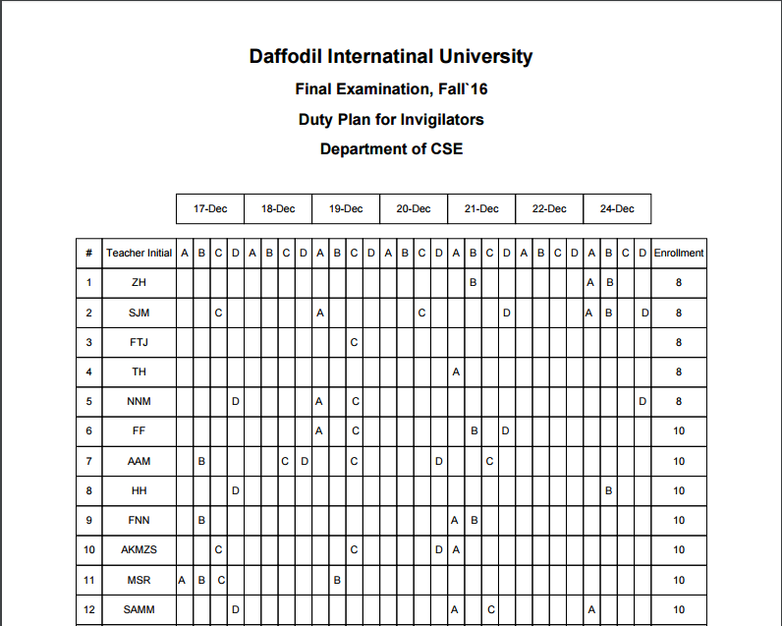

Figure 5.1.12.1: Report of Duty Plan

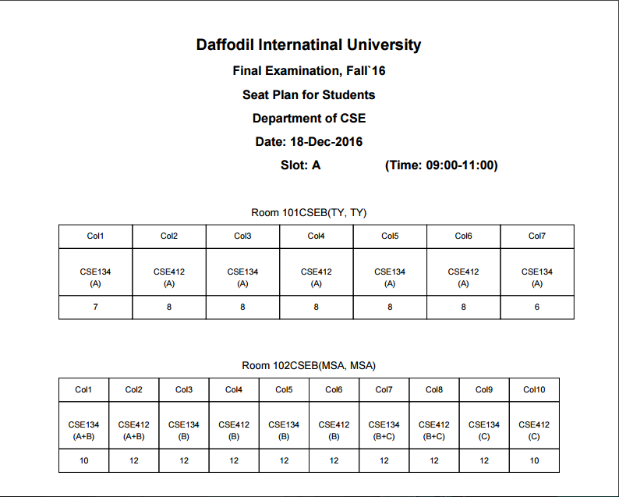

Figure 5.1.12.2: Report of Seat Plan

**CHAPTER 6**

**TESTING**

6.1 TESTING OF THE SYSTEM

Testing is a set of activity that can be planned in advance and conducted systematically. Developer of the software and an independent test group conducts testing. The software should be tested for expected result and efficiency after implementation of the system. Because during implementation everything may not be done according to the system design. So without testing those errors cannot be detected and then corrected. Therefore system testing is very important phase of a system development. Testing and debugging are different activities, but debugging must be accommodating in any testing strategy. Here we have discussed about different testing those we had conducted to make the system perfect. There are: [12]

6.2 UNIT TESTING

Unit testing focuses verification effort on the smallest unit of the system design the software component or module. All the inputs taken each module will be tested by testing data and different in results before and after adding validation will be shown. Different tests be conducted as part of unit testing are as follows:

1. Interface testing
2. Local data structure testing
3. Error handling paths testing
4. Boundary condition testing
5. Independent paths testing
6. Execution path testing

During the design of the system we had conducted these tests frequently.

6.3 INTEGRATION TESTING

Integration testing is a systematic technique for constructing the system architecture while at the same time conducting test to uncover errors associated with interface. The objective is to take unit tested component and build a program structure that has been dictated design.

We have conducted this tests. We checked the login system that without user ID and password none can access main system. We checked all the units of the proposed modules whether all the information needed are being fetched perfectly. We checked whether different teacher are being set for two different room.

6.4 SYSTEM TESTING

System testing involves testing of the complete set of application program. This testing will be carried out to ensure that the program can be meet the demands of users. If would check the functionality of the proposed system. The test would pick the areas that need to be modified any omission or deficiencies in the way the system works. We designed algorithms for the processes according to the manual approach performed by the university exam control board. Proposed algorithms didn’t give expected result and failed while testing. We corrected the algorithms several times and tested the results. After few approaches, the test gave correct and expected results. In some portion, it gave expected result though the algorithm was not perfect. After several testes it shows up the flaws. For example, while designing the seat plan, it gave expected result for two courses in a slot. But coming to three courses it messed-up. By testing we perfected our algorithm and developed the final absolute algorithm.

**CHAPTER 7**

**CONCLUSION**

7.1 DISCUSSION

Exam automation system is very easy to operate for every user. The system we have developed, fulfill our target with all the requirement. Though it fulfills all the related requirement, further we want to improve it, as it work more efficient and effective in future. The work as well as the technology is changing so rapidly that before we are being familiar with one technology another raises. There are some limitation in this system in which we have to work in future.

7.2 LIMITATION

This project has some limitations. The database has information of only one department. The routine creating module is not automated yet. Only two teachers are set for duty plan in each room.

7.3 FUTURE SCOPE

This project work can be developed in future with eliminating limitations and including more activities such as:

1. Full database with information of all departments of the University
2. Automated exam routine preparation.
3. Number of Invigilators according to the size of rooms.

**REFERENCES**

1. Introductory Process in Software Development, [Online Available form], <http://www.cbd-hq.com>, Visited Date: December 8, 2016.
2. SDLC, Roger S. Pressman, “Software Engineering” 6th Edition, pp. 368-411, 2005.
3. Elias, M. Awad, “System Analysis and Design”, 2nd Edition, pp. 45-51, 170-186, 335-336, 1997.
4. Shelly, G. B. and Rosenblatt, H. J., “Analyzing the Business Case” in “Systems Analysis and Design”, 8th Edition, Kathleen McMahon, Canada, PA: GEX Publishing Services, pp. 63-65, 2006.
5. R. T. Justis & B. Kreigsmann,. The feasibility study as a tool for venture analysis. Business Journal of Small Business Management 17 (1) 35-42, 1979.
6. J. A. O'Brien & G. M. Marakas, Developing Business/IT Solutions. In Management Information Systems, New York, NY: McGraw-Hill/Irwin, pp. 488-489, 2011.
7. Benjamin S. Blanchard & Wolt Fabrycky (uk).” Systems Engineering & Analysis”. 5th ed. (pp. 361).
8. Dave, W. Mercer et al, “BEGINNING PHP5” Edition, Chapter – I, pp. 12-23, 2004.
9. Shelly, G. B. and Rosenblatt, H. J., “Systems Design” in “Systems Analysis and Design”, 8th Edition, Kathleen McMahon, Canada, PA: GEX Publishing Services, pp. 402, 2006
10. A. Silberschatz, “Database System Concept”, 5th Edition, pp. 202-245, 2006.
11. Shelly, G. B. and Rosenblatt, H. J., “Systems Analysis” in “Systems Analysis and Design”, 8th Edition, Kathleen McMahon, Canada, PA: GEX Publishing Services, pp. 198, 2006.
12. William, E. Lewis, “Software Testing and Continues Quality Improvement”, CRC press, Chapter-9, pp. 56-78, 2000.